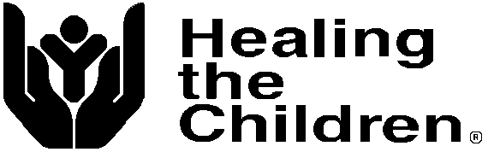
Florida/Georgia, Inc. Tax I.D. # 59-3503974
PO Box 608432 Phone Voice: 1 407 877 9311
Orlando, Florida 32860

HEALING THE CHILDREN FLORIDA, INC., ANNUAL REPORT – 2018
Healing the Children Florida, Inc., is a Florida based not for profit organization holding a
501 © (3) tax exemption with the IRS. Our tax exempt number is 59-3503974. HTCFLA
provides specialized medical treatment to children in need worldwide including the USA.
These services are provided through four core service programs detailed below:

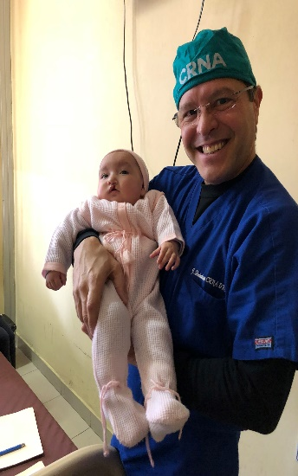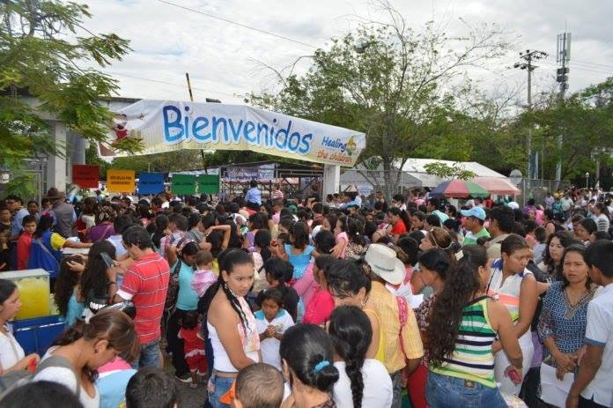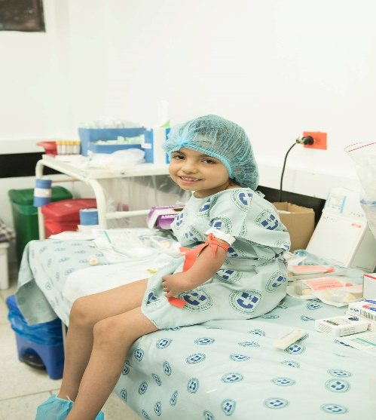

Medical Trips Program -
As an organization working internationally to meet the needs of poor children in
developing countries, HTC organizes and transports volunteer surgical teams to a preselected and approved hospital site. Sites must meet specific and well-defined criteria before being considered as a program site for HTC. Local and national governmental and civic relationships are established to ensure a smooth implementation of our program, which will maximize benefits to our patients.
During 2018, HTC Florida conducted (4) medical trips. These included trips Colombia, China, Guatemala, Ecuador specializing in orthopedics, maxillofacial/cleft lip and palate, and burns.
Our ancillary support program in Neiva, Colombia for children with Cleft Lips and Palates provided 100 bracket cases were provided year- round care, speech therapy sessions for total of 275 hours of speech therapy. Families received hands on instruction and material to aid in establishing and improving speech in their children. All our missions include educational tutoring, and lecturing provided at no cost to host hospital medical staff.

A total of 851 patients were screened and evaluated by our volunteer team members. The patients selected for surgery/ provided with donated care were 336. Donated services provided were $1,056,708.

Healing the Children, Florida is grateful to all their donors and sponsor. Special thanks to Masonic Benevolence Fund, Biomet, Stryker, RealSelf Fellowship, Fort Lauderdale Surgical Society for their support and contribution to our Medical Trips Programs. Thank you also to all our donors, volunteers and friends for their continued commitment to the Healing the Children mission - “Healing the Children, Around the Corner, Around the World!”

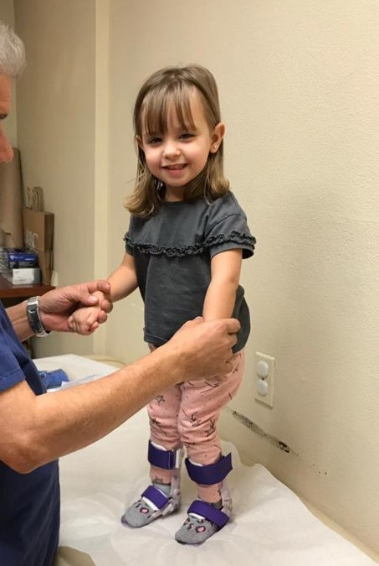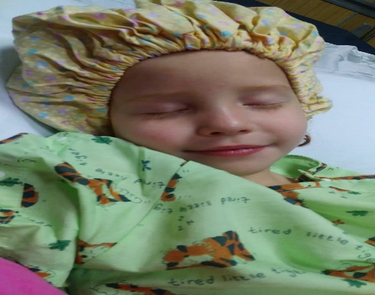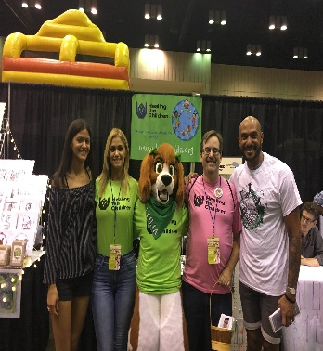

Domestic Program – (Aid to American Kids)

This program aims to provide children with life changing and life altering medical care.
Due to the increasing number of children who remain uninsured due to parental
immigration status, parents’ lack of awareness of service available to them and financial
constraints, many children with special medical needs, go untreated or identified. Healing the children has partnered with local clinics and agencies to help meet the needs of these children. We have made arrangements to utilize office in the Central Florida area to address the needs of local children.
Its primary focus is to treat the special medical, developmental needs
of needs of children from low income families, who have no health insurance and
are not eligible for any insurance or programs, even those at a local or state level. Our
secondary focus is to identify those families whose child’s special condition puts the
family in financial crisis despite having health insurance. HTC receives and accepts referrals from local agencies such as local clinics, the health departments, and professional healthcare providers. We recruit specialist from varying medical areas.
H TC also provides transportation and prescription assistance when necessary. Area volunteers are recruited to provide transportation to and from clinic appointments as needed. If a volunteer is not available, we provide some financial assistance for bus fare or a gas card is provided. As well as providing specialized care, HTC provides educational information that addresses and encourages good health as well as child safety. Our primary care physician referral network continues to match uninsured children with a volunteer physician in the community willing to accept the patient at no cost to the parents. Our case management staff carefully screens each patient and makes the appropriate referral to a specialist, who has the responsibility of accepting or not accepting the referral. One of our major goals is to decrease the number of children with special medical and developmental needs not receiving care due to lack of insurance or financial constraints. Our success is measured by the number placements we make and the acceptance by a healthcare provider for treatment of the children we identify and are deemed treatable by the treatment team.

The direct and indirect outcomes of our project are -
. an increase in the quality of life and life expectancy of the children we serve;
. decrease in familial stress;
. decrease in the number of children living in poverty who lack proper medical health.
. decrease the number of emergency room visits made by families with children who
have special needs, who use the E.R. as a primary care provider.
Healing the Children strives to significantly increase the quality of medical treatment to
children in our local communities who lack appropriate medical care. As an organization HTC takes great pride in the high-level professional care we are able to provide our patients. We believe in our mission and through the actions of our volunteers and results, we have proven to be a leader in the field of humanitarian health care. Our volunteers are dedicated individuals who have selflessly given of their time to provide medical care in extraordinary circumstances. We are confident in our ability to dynamically impact the lives of children who are in dire need of medical care in our local communities.

Healing the Children Florida, Inc. is a member of CFC and local United Ways.

During 2018 48 children were provided in-kind services totaling $ 94,612.90. Services provided included access to specialist, ancillary support services, advocacy support and case management services. Thank you also to all our donors, volunteers and friends for their continued commitment to the Healing the Children. We would like to especially thank all our volunteer medical professionals, Advent Health, Wawa Foundation and Vivint Smart Home.

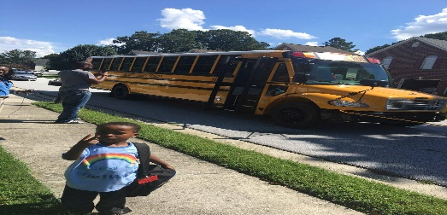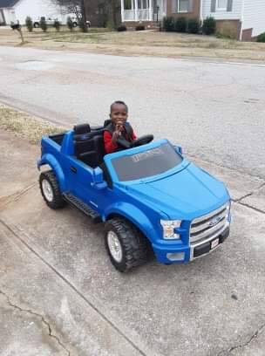

The International Inbound Program coordinates donated medical services for children
from foreign countries who travel to the United States where they receive specialized
medical care. Specialties have included heart surgery, reconstructive surgery, orthopedic surgery, ENT surgery, cardiac, orthopedic, urology, maxillofacial and pediatric surgery as well as general surgery. HTC works with hospitals all across Florida and Georgia. The children are often placed with a host family while they are receiving treatment. During calendar 2018, 1 child was helped internationally. The donated in-kind services for this program in 2018 was $ 288,831. The child helped was from the country of Liberia.

Special Projects:

Hope for Gladys: Due to the generosity of our supporters Healing the Children sponsored the education of a child and her sibling who were once sponsored through our International Inbound Program. Cost of tuition for 2018: $700

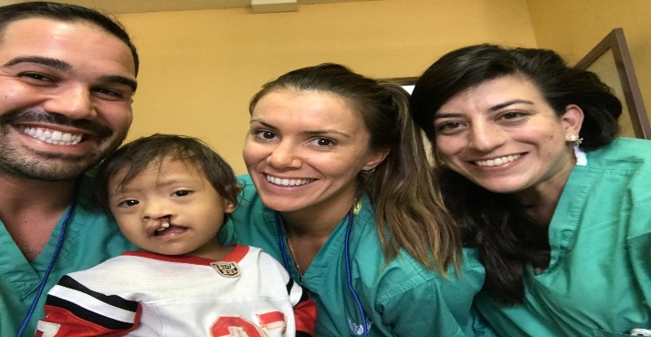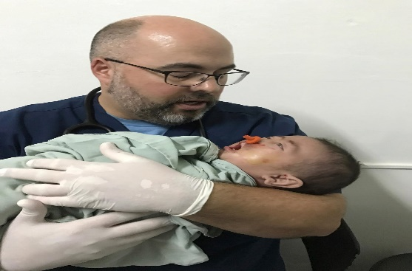

Home of Bright Choices: Healing the Children recently partnered with Home of Bright Choices a new not for profit dedicated to filling gaps for individuals with special needs with life skills and independent living skills. $ 4,900.00

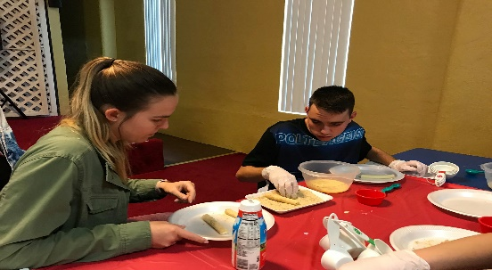

The total amount of in services provided to the patients we
served during 2018 was $ 1,445,751.90
Healing the Children Florida, Inc, was able to accomplish all of its goals for 2018 on a combined income of $ 84,459.00.
Healing the Children Florida/Georgia

