HEALING THE CHILDREN FLORIDA, INC., ANNUAL REPORT – 2021
Healing the Children Florida, Inc., is a Florida (HTCFLA) based not for profit organization holding a 501 © (3) tax exemption with the IRS. Our tax-exempt number is 59-3503974. HTCFLA provides specialized medical treatment to children in need worldwide including the USA.

These services are provided through four core service programs detailed below:

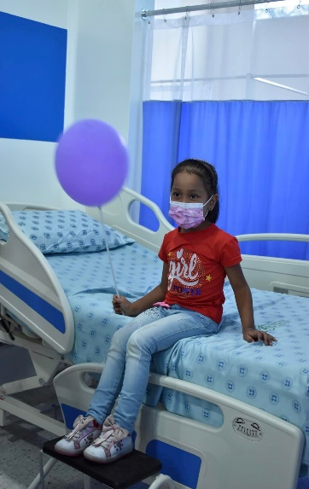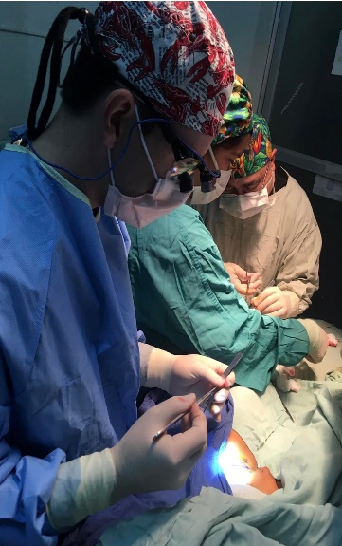

Medical Trips Program -
As an organization working internationally to meet the needs of poor children in
developing countries, HTC organizes and transports volunteer surgical teams to a preselected and approved hospital site. Sites must meet specific and well-defined criteria before being considered as a program site for HTC. Local and national governmental and civic relationships are established to ensure a smooth implementation of our program, which will maximize benefits to our patients.
During 2021 we had our first mission post COVID-19 and HTC Florida conducted (1) medical trip. HTC volunteers traveled to Colombia. The team was small. This was necessary due to COVID-19 protocols. We needed to limit large groupings of people, staff, patients, and their families. We only accepted vaccinated staff members and all patients over 16 had to be vaccinated to be eligible for the mission. Family members with the patient had the same requirement. The team provided medical treatment in orthopedics, maxillofacial/cleft lip and palate deformities and plastic surgery.
A total of 100 patients were screened and evaluated by our volunteer medical team. The patients selected for surgery/ provided with donated care were 33.
Total Donated services provided were $130,000.00

Healing the Children, Florida is grateful to all the donors and sponsors who participated in this mission trip.. Thank you also to all our donors, volunteers and friends for their continued commitment to the Healing the Children mission - “Healing the Children, Around the Corner, Around the World!”
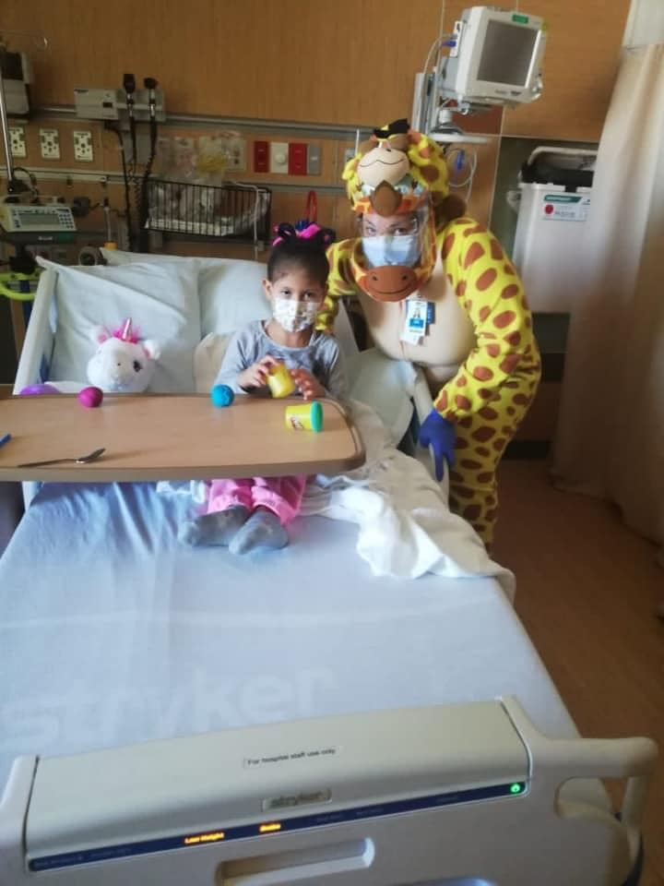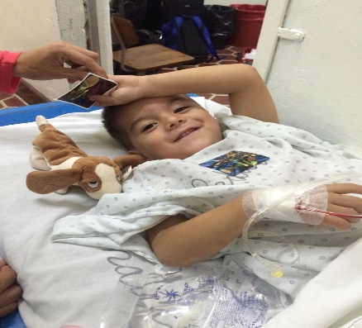

Domestic Program –

This program aims to provide children with medical problems that will alter and change their lives as soon as they are born. Due to the increasing number of children who remain uninsured in our Country due to parental immigration status, parents’ lack of awareness of services available to them; and due to financial constraints, many children with special medical needs, are not identified and go untreated for many years. Healing the children has partnered with local clinics and agencies to help meet the needs of these children.
Children who have no health insurance and
are not eligible for insurance, or programs, at the local or state level. Our
secondary focus is to identify those families whose child’s special condition puts the
family in financial crisis despite having health insurance. HTC receives and accepts referrals from local agencies such as clinics, the health departments, and professional healthcare providers. We recruit specialists from different areas and specialties. HTC also provides transportation and prescription assistance when necessary.

Area volunteers were recruited to provide transportation to and from clinic appointments. If a volunteer is not available, we provide some financial assistance for bus fare, or a gas card is provided. As well as providing specialized care, HTC provides educational information that addresses and encourages good health as well as child safety. Our primary care physician referral network continues to match uninsured children with a volunteer physician in the community willing to accept the patient at no cost to the parents. Our case management staff carefully screens each patient and makes the appropriate referral to a specialist, who has the responsibility of accepting or not accepting the referral. One of our major goals is to decrease the number of children with special medical and developmental needs not receiving care due to lack of insurance or financial constraints. Our success is measured by the number placements we make and the acceptance by a healthcare provider for treatment of the children we identify who are deemed treatable by the individual treatment team.

The direct and indirect outcomes of our project are -
. an increase in the quality of life and life expectancy of the children we serve;
. decrease in familial stress;
. decrease in the number of children living in poverty who lack proper medical health.
. decrease the number of emergency room visits made by families with children who
have special needs, who use the E.R. as a primary care provider.

Healing the Children strives to significantly increase the quality of medical treatment to
children in our local communities who lack appropriate medical care. As an organization HTC takes great pride in the high-level professional care, we can provide our patients. We believe in our mission and through the actions of our volunteers and results, we have proven to be a leader in the field of humanitarian health care. Our volunteers are dedicated individuals who have selflessly given of their time to provide medical care in extraordinary circumstances. We are confident in our ability to dynamically impact the lives of children in our local communities
who are in great need of medical treatment.

Healing the Children Florida, Inc. is a member of Combined Federal Campaign and local Chapters of United Way.

During 2021, 15 children were provided in-kind services totaling $ $48,287.00
Services provided included access to medical specialist, ancillary support services, advocacy support and case management services. Thank you to all our donors, volunteers, and friends for their continued commitment to the Healing the Children

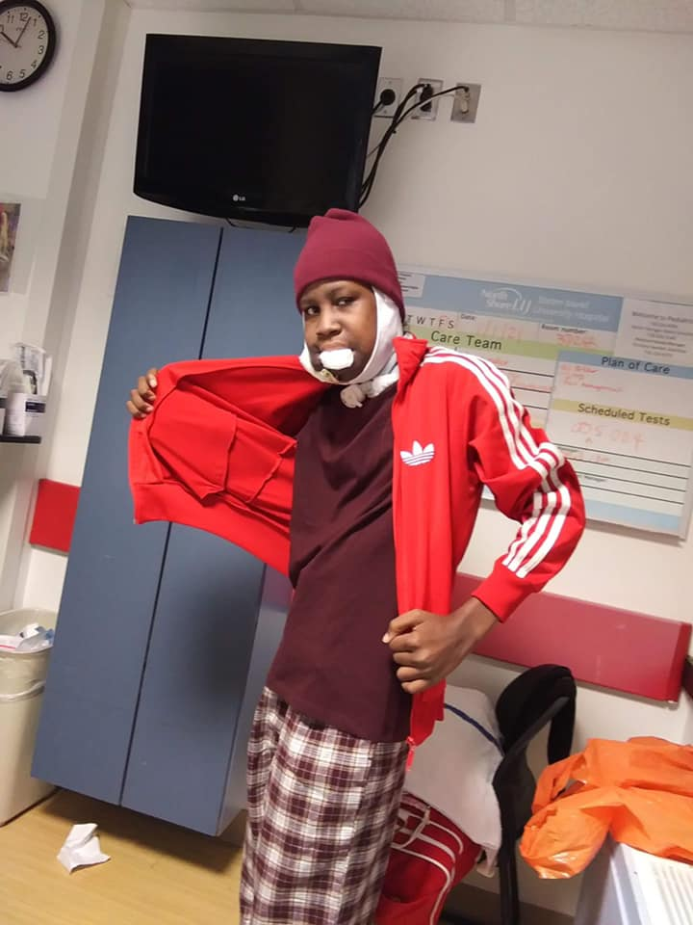

Elijah from Liberia post-surgery. Doctors removed a 20 lb. tumor from his jaw and thus saving his life.

The International Inbound Program coordinates donated medical services for 1 child
from the countries of Liberia. They traveled to the United States to receive specialized medical care. The Specialties we have provided care for over the last 23 years include heart surgery, plastic reconstructive surgery, orthopedic surgery, ENT surgery, urology, maxillofacial and pediatric surgery as well as general surgery. HTC works with hospitals across US, including Florida and Georgia who accept these children at no cost to the organization. The children are often placed with a host family while they are receiving treatment in the community and/or state where they are accepted by a physician and hospital.

During calendar 2021, 1 child was helped internationally. The donated in-kind services for this program in 2021 was $800,000.00.

Special Projects:

In response to COVID 19, a food pantry was established for 10 families in our program where 1500 lbs. of food was distributed.
A toy drive was held for at-risk children and over $5000 worth of toys were donated to children in need.

Healing the Children supported Home of Bright Choices for the 4th year and helped provide an inclusive life skill, and social skill class to 12 individuals. $3000.00 estimated value

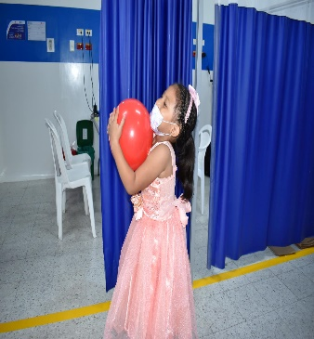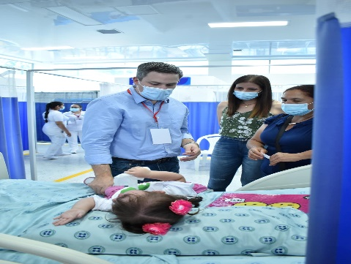

The total amount of in-kind services provided to all the patients we served during 2021 was
$986,287.00

Healing the Children Florida, Inc, was able to accomplish all of its goals for 2021 on a combined income of $ 55,457.14.

Respectfully Submitted,

Healing the Children Florida/Georgia, Inc.

